
INDEX
Syed Ali Ahmed & Syed Rabbet Hassan (section D)

REPORT WRITING: CODe ANALAYSIS
VOTING SYSTEM

- Index page 1
- Introduction page 2
- Idea page 3
- Algorithm page 3
- Abstract page 10
- Flowchart page 12
- Conclusion page 15

- Introduction
TO: Sir Abdullah,
From: CT-196 &197,
Date: 8/11/2025,
Subject: A detailed analysis into Our code of Voting System.
Respected Sir;
I am writing this report to introduce you to our topic for end of first semester 2025 programming fundamental assignment, which is about the Voting-System”. Since the goal of this project was to display our acquired skills of coding and understand as well as team coordination with respect to selectin, writing and explaining the code written on the chosen topic we found this subject of a voting system to be ideal.

- Ideas:
An ideal voting system must come with its sets of criteria and principles on which an individual having a certain data that matches the criteria falls in the category of Eligibility.
Which includes the following:
- Name
- Citizen ship
- Age
- Gender
- CNIC (proof of his nationality)
- His Status (in country/or/abroad/or/visiting)
- Employment
- Type of Employment

With the most important being:

- Citizen ship (person voting must be of this country)
- Name (person uses his real name or not to fake it)
- CNIC (person has proof of his nationality)
- Age (person must be at least 18)

- Algorithm:
Its basic Algorithm written inform of pseudocode is:
STEPS:
- Start
- Declare variables:
  - d, i
  - Arrays: citizen[d][20], age[d], gender[d], cnic[d], status[d], working[d], job Type[d]
- Ask user:
→ “Enter number of people” → read d.
- Loop from i = 0 to d - 1:
a. Print header for Person i+1.
b. Input:
  - citizen[i]
  - age[i]
  - gender[i]
  - cnic[i]
  - status[i]
  - working[i]
c. If working[i] == 1, then input job Type[i], else set job Type[i] = 0.
- Open file "voting_results.txt" in write mode.
- Print header line: "===== Voting Eligibility Results =====".
- Loop again from i = 0 to d - 1:
a. Display and write:
  - Citizen, Age, CNIC status, and Country status.
b. Check voting eligibility:
  - If citizen[i] == "Pakistan" AND age[i] >= 18 AND age[i] < 110 AND cnic[i] == 1,
→ Print & Write "Eligible to Vote".
  - Else → Print & Write "Not Eligible to Vote".
c. Check work status:
  - If working[i] == 1:
    - If job Type[i] == 1 → Write "Government Worker".
    - If job Type[i] == 2 → Write "Private Worker".
  - Else → Write "Jobless".
- Close the file.
- End.
The program written in C programming language;
Explaining each chunk of code :

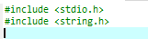
- Purpose: These header files stdio.h allow standard input out function whereas string.h allow the program to use string functions like strcmp, strcpy, etc.
- Why here: Without this, the strcmp function used later in the program to compare strings would not work. C does not treat strings as first-class objects like some languages. Strings are arrays of characters, and operations like comparison (==) cannot be done directly; you need “strcmp”.

Purpose: Declares two integer variables:
- (d)= stores the data for number of people the user wants to enter data for.
- (i)= is used as a loop counter in for loops.
Why: We need a loop counter to iterate through multiple people's data and d to know how many times to loop.
- Purpose: These are arrays to store multiple pieces of information for each person:
  - age[d] → ages of all d people.
  - gender[d] → gender choices of all d people.
  - cnic[d] → CNIC possession (Yes/No) for all d people.
  - status[d] → whether they are abroad or in country.
  - working[d] → whether they are working or not.
  - jobType[d] → if working, whether government/private.
- Why arrays: Arrays are used because we are storing multiple values of the same type. Instead of making separate variables like age1, age2, ..., we store them in a single array.
- Key concept: Array indexing (age[i]) allows us to access each person’s info during loops.
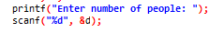
- Purpose: Takes input from the user and stores it in d.
- Why: The program is dynamic; it can handle any number of people instead of a fixed number. Using scanf lets the user decide how many people's data will be entered.
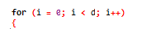
- Purpose: A for loop to iterate from 0 to d-1, i.e., once for each person.
- Why here: This loop collects input for each person dynamically.
- Why for loop: For loops are ideal when the number of iterations is known beforehand (we know d from the user).
- Purpose: Prints a heading for each person's input section.
- Why i+1 instead of i: Arrays are 0-indexed (0,1,2, ….), but for display to the user, it’s more natural to show Person 1, Person 2, ….

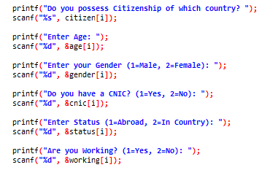
- Purpose: Asking the user to input the following data with respect to the data types.
- Why: So program can store this data in array which will be later used to determine whether the person is eligible to vote.
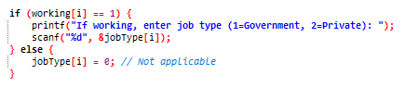
- Purpose: Assigns a default value to jobType[i] if the person is not working.
- Why: Prevents garbage/uninitialized data. If the person is not working, jobType is meaningless, so we assign 0.

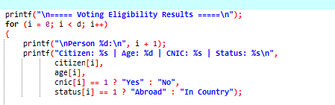
- Purpose: Another loop to display results for each person.
- Why a loop again: We need to iterate through all entered people to print their details and check eligibility.

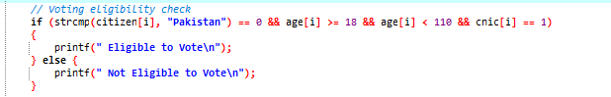
- Purpose: Checks voting eligibility using multiple conditions:
  - strcmp(citizen[i], "Pakistan") == 0 → Checks if the person is a citizen of Pakistan. The function strcmp is used because strings cannot be compared with == in C.
    - Returns 0 if strings are exactly equal.
b) age[i] >= 18 && age[i] < 110 → Age requirement (legal voting age).
C) cnic[i] == 1 → Must have CNIC.
- Why if: Branching is needed to determine eligibility and display different outputs accordingly.

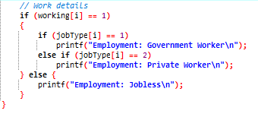
• Purpose: Prints info for people who are not working.
• Why: Ensures output is complete and accurate for all cases.
• Purpose: Checks if the person is working.
• Why: Only working people have a job type. Branching avoids unnecessary printing or wrong info.
- Inside this if, another if determines government vs private, making it a nested decision.
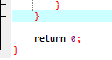
• Purpose: Ends the main function and returns 0 to the operating system.
• Why: In C, returning 0 usually signals successful execution of the program.

- Abstract:
This C program implements a voting eligibility system that collects and processes personal information of multiple individuals using arrays. For each individual, the program records their citizenship, age, CNIC possession, current status (abroad or in-country), and employment details (jobless, government, or private worker). The program then evaluates whether each individual is eligible to vote based on the criteria: being a citizen of Pakistan, aged between 18 and 109 years, and possessing a valid CNIC. The results, including voting eligibility and employment details, are displayed for each individual. This program demonstrates the use of arrays for storing multiple entries, conditional statements for eligibility checks, and string comparison functions to verify citizenship.
- Excel Data To Be Input
Name | Gender | Citizenship | Age | CNIC | Status (Abroad or In Country) | Employed (Working/Jobless) | Government Worker/or/Private Worker | Notes
Ali Khan | Male | Pakistani | 35 | 42101-9876543-2 | In Country | Working | Private Worker | Software Engineer
Ayesha Bibi | Female | Pakistani | 22 | 42101-1234567-8 | Abroad | Jobless | N/A | Studying in Canada
Javed Sadiq | Male | Pakistani | 55 | 42101-5432109-8 | In Country | Working | Government Worker | Teacher
Sara Ahmed | Female | Pakistani | 45 | 42101-0987654-3 | In Country | Working | Private Worker | Freelance Writer
Haroon Malik | Male | Pakistani | 62 | 42101-1122334-4 | In Country | Jobless | N/A | Recently retired from WAPDA
Fatima Waseem | Female | Pakistani | 28 | 42101-2233445-5 | Abroad | Working | Private Worker | Nurse in UAE
Bilal Hassan | Male | Pakistani | 31 | 42101-3344556-6 | In Country | Working | Private Worker | Bank Manager
Mehak Zafar | Female | Pakistani | 19 | 42101-4455667-7 | In Country | Jobless | N/A | University freshman
Taimur Shah | Male | Pakistani | 40 | 42101-5566778-8 | Abroad | Working | Government Worker | Diplomat
Rubina Pervez | Female | Pakistani | 50 | 42101-6677889-9 | In Country | Working | Government Worker | Senior Administrator
Daniyal Khan | Male | Pakistani | 25 | 42101-7788990-0 | In Country | Jobless | N/A | Seeking first job
Hina Riaz | Female | Pakistani | 38 | 42101-8899001-1 | In Country | Working | Private Worker | Graphic Designer
Omer Farooq | Male | Pakistani | 58 | 42101-9900112-2 | In Country | Working | Government Worker | Consultant
Anam Lodhi | Female | Pakistani | 29 | 42101-0011223-3 | Abroad | Working | Private Worker | Online Tutor
Wasim Akram | Male | Pakistani | 42 | 42101-1122330-0 | In Country | Working | Private Worker | Factory Supervisor

- Flowchart
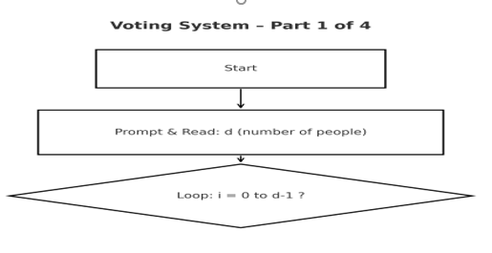
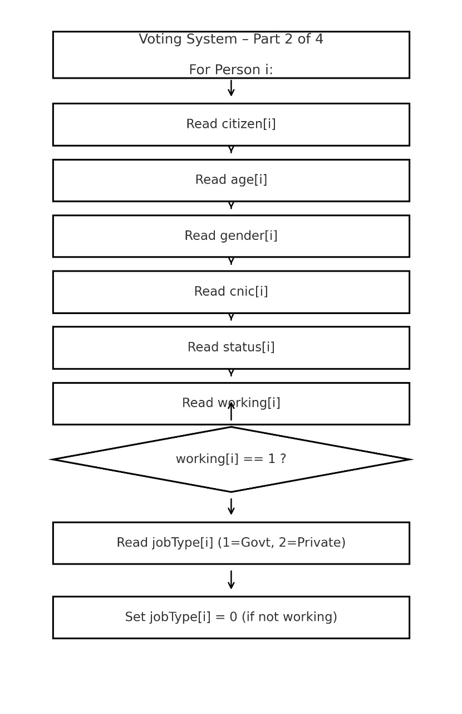

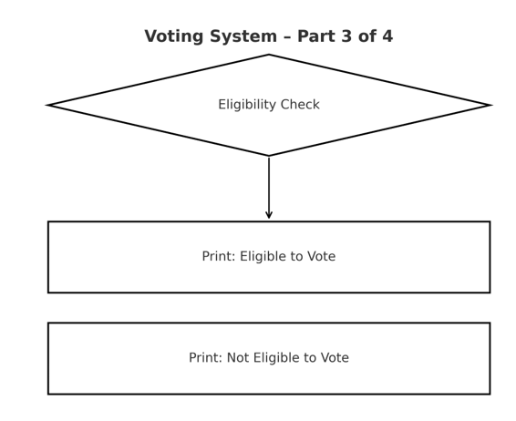
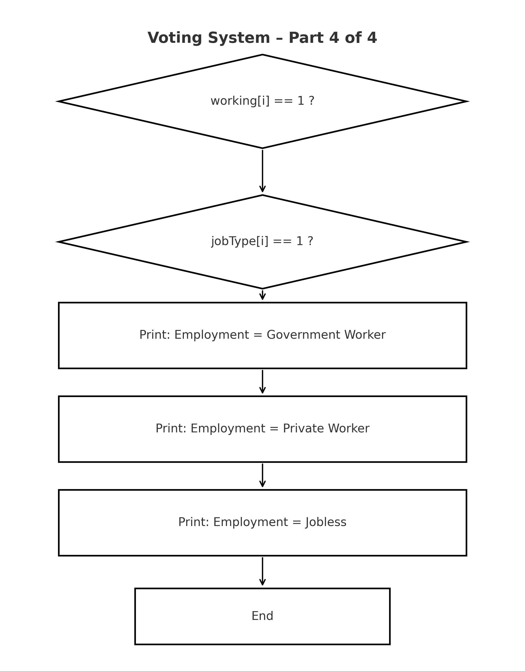
- Conclusion:
This project successfully demonstrates how programming concepts such as arrays, loops, and conditional statements can be applied to simulate a real-world voting system. Through this implementation, we learned to handle user input dynamically and evaluate eligibility based on specific conditions. Overall, the program reflects a strong understanding of logical problem-solving and structured coding in C.

